Water Spreading Weir (WSW) | (1) Implementation Period/Phases  Only during dry season and minimum one month before rains occur. |  |  |  |  |  |  | (2) Definition/Objective  WSWs are masonry structures that span the entire width of a river bed or large parts of a valley floor. A WSW is a floodwater farming technique where runoff waters are spread in valley bottoms of seasonal riverbeds, large gullies or natural water courses for improved crop and forage production.  For optimal results, WSWs are built in cascades consisting of three or more WSWs.
(3) Suitability, ecology and adaptability based upon local knowledge  WSWs can be used under the following conditions:  - Rainfall: 200 – 750 mm;  - Climate: Arid to semi-arid areas;  - Soil: For all agricultural soils;  - Slopes: Best below 2% for most effective water spreading effect;  - Topography: Wide, shallow valleys with dry river beds. |  |  |  |  |  | (4) Main land use  The WSW approach is suitable for all land uses. Especially dry river valley bottoms for improved crop and forage productions, using the residual moisture of the river bed sediment.
(5) Technical preparedness  Agree with communities on locations, user rights and maintenance.  Provide the input of engineers for the initial design and profile.  Setting out should be done by surveyors together with the foreman.  Construction should be done by experienced masons under supervision of a foreman and experienced technical personnel. |  |  | (6) Description of the technology and steps  WSWs are non-permeable, low-based masonry structures. They are built in a right angle to the water flow forming a horizontal line. A WSW should ideally span a whole valley or it can be constructed in dry river beds and has an important water spreading effect.  Steps on WSW study and design:  1. Preliminary study  2. Site selection  3. Design  4. Setting out  5. Construction of the wings  6. Construction of walls and basin(s) in the main spillway |  |  |  |  |  |  |  |  | (7) Minimum surveying and tools requirements  Layout: one theodolite, range poles, string rope, measuring tape of 50-meter length, spirit level, spray paint, machete, hammer, shovel and pick axe.  Construction: Shovel, hammer, sledge hammer, spirit level, float, mason trowel, string, wooden sticks, measuring box, watering can and equipment to carry stones, cement, water, stones, gravel and sand.
(8) Design & technical standards  To prepare the mortar, cement and sand are mixed in a ratio of 1:4. This is then mixed with plenty of water.  For construction large, rough stones with a diameter of more than 30 cm should be used. Working in layers should be prevented. The upper part of the WSW should never be smoothed with mortar because a rough surface diffuses the energy of water better.  For the design of the WSW standard tables are being used. They are shown in the TTLM on WSW. |  | (9) Layout and vertical intervals/ Construction Procedures  The distance between two WSW depends on the topography and the slope of the river valley. WSWs are low-based masonry structures made of stones and cement. Each WSW consists of a spillway, one or more basins in the riverbed itself and lateral abutments or wing walls which stabilize the structure and are decreasing in height away from the spillway.  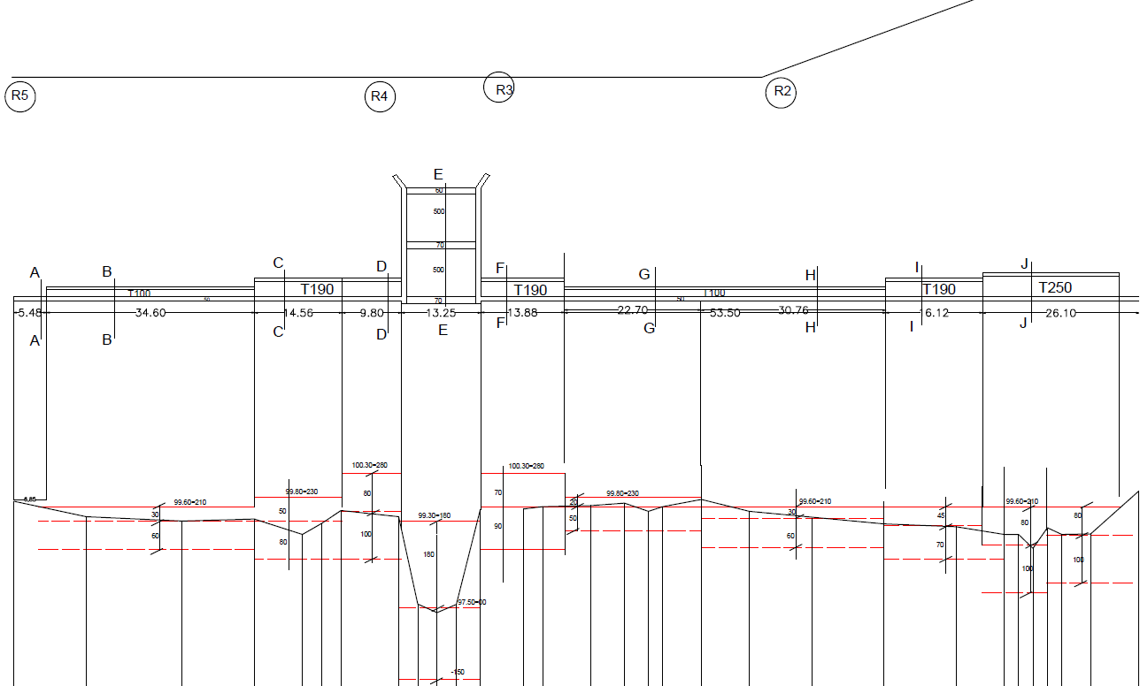  Fig. 2: The technical plan of a WSW consists of a profile and a top view plan including all sections. Here, the spill over basins in the riverbed with stabilizing abutments left and right, as well as the different sections of the wings in relation to the profile of the river bed and the adjacent valley floor are shown. In additional technical drawings the sections are shown in more detail for construction.
(10) Work norm  WSW construction needs skilled masons. Community members can be involved in site clearing; stone and sand collection, excavation and back fill as well as mason assistance.  Minimum work norm:  Stone collection 0.5 m³/Pd  Excavation: 0.75 m3/Pd  Mortar preparation: 0.7 m³/Pd  Masonry work: 1 m³/Pd |  |  |  | (11) Integration opportunities/requirements /use  One weir alone will rarely solve all the erosion problems of a wide valley. Weirs should be constructed in cascades. WSWs should be combined with other soil and/or water conservation measures such as Dry-Stone Measures and biological conservation measures.  WSWs can be combined with area enclosures.  WSWs can be combined with a group formation to ensure sustainability of the measure. |  |  |  |  |  |  |  |  |  | (12) Modiﬁcations/adaptation to the standard design - Flexibility + Linkages  The standard designs (refer to Nr.22) can be adapted according to local situation (soil structure, flood levels).
13) Planning and implementation arrangement  Based on the design, an estimation for the amount of stones, sand, cement, water, masons and daily laborers is done. Organize construction logstics. Setting out of WSW followed by excavation. Construction of fundament, wing walls,spillway and basins.  NOTE: Daily watering of the structure is necessary to ensure proper bonding of the cement. |  |  |  |  |  |  | (14) Likely adverse impacts & Mitigation  Adverse impact might be the creation of new erosion systems. This can be mitigated by putting in place biological control measures.  During rainy season, WSWs should be regularly checked for damage and be maintained. Further gully erosion downstream of the WSW and destruction of the WSW itself is a potential risk if maintenance doesn’t take place in time. |  |  |  | (15) Potential to increase/sustain productivity and environmental protection  Large amounts of sedimentation are kept behind the structures, providing fertile soil for food and fodder production. Land below the structure is protected from erosion. Water infiltration will also increase in the area below the WSW, contributing to increased water availability.
(16) Climate Change/Disaster Risk Reduction  Increased resilience to climate change in regions experiencing higher variability of rainfall due to higher infiltration rates and erosion prevention. |  |  |  |  | (17) Potential to Livelihood contribution  Increased options for income generating activities (IGA) through local production, such as vegetables or fruits on the fertile land. Rangelands are saved from destructive erosion. |  |  |  | (19) Operation & Management requirements  A WSW can be managed by the community. The community needs to be organized in a group with supportive bylaws to improve sustainability.
(20) Institutional responsibility  In WSW study and design clan leaders, community representatives kebele leaders, NRM experts and Development Agents need to be involved. Kebele leaders and community representatives are responsible for organization of community meetings, discussion, and contribution of community. NRM experts and engineers are responsible for technical designs, technical support, setting out and assure availability of material that cannot be covered by the community. |  |  |  |  |  |  |  |  |  | (21) Limitations / Constraints  WSW construction requires technical skills for design, setting out and construction. The responsibilities for maintenance need to be clarified in advance with the community.
(22) Table, Formula, Calculation/Figure/Pictures/Design Layouts/Design Diagrams  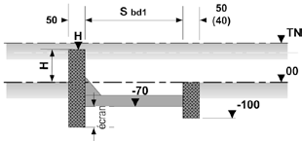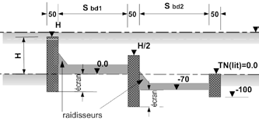 |  |  |  |  |  |  |  |  |  |  |  |  | (23) Other: refer to the annex for more information in the TTLM on DSM  For more information see:  Teaching, Training and Learning Material on WSW  Standard Designs  Do’s and Don’ts for construction  prepared by GIZ-SDR

