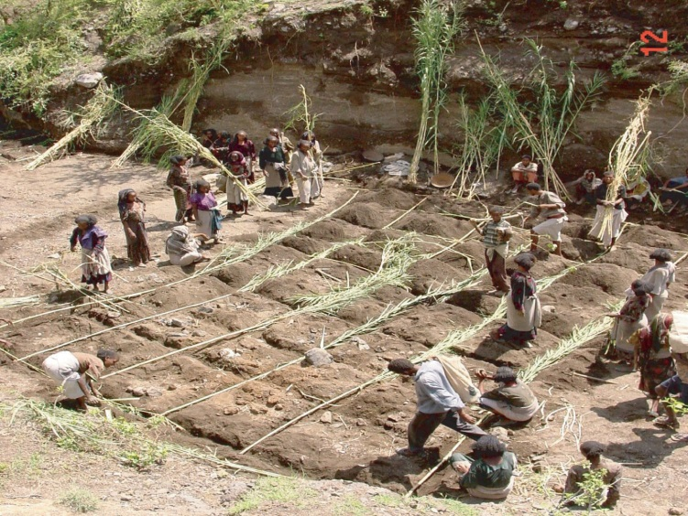
TECHNICAL INFORMATION KIT | (1) Period/phases for imple- |  | (2) Main objective/purpose
LIVE CHECK DAMS | During the rainy season |  | Live check-dams are established by planting/ seeding or plugging of cuttings in gully bottoms to replace or reinforce physical check-dams. The main objective of the establishment of live check-dams is to reduce the cost of establish- ing physical check-dams. Live check-dams can be applied by individual farmers and does not need the organization of a large group of people to undertake physical structures.
(3) Suitability and adaptability to local knowledge
Gullies and dry river beds with low to medium slopes
(4) Potential to increase/sustain productivity and environmental protection
The biomass produced is an immense contribution to animal fodder as well as fuel wood, poles and other wood products.
(5)Technology description |  |  | (6) Minimum tools/requirements
Woody plant boxes: Poplar, willow or other suitable species stems with a diameter of 2-4 cm and a length of 70 cm are inserted 20 cm deep next to each other across the gully ﬂoor spaced 50 cm apart. The space in between the rows is ﬁlled with stems of the same species. This works in gully ﬂoor within the soil and should be established at the beginning of the rainy season.  Reinforced Bundling/wattling  It is a technique where fresh stems of plants (e.g. elephant grass, bana grass, Spanish reed, poplars, willows) are bound together, horizontally planted and covered by soil. The use of other organic matter (e.g. straw, tree branches) may be used to economize on fresh planting material. Fresh vegetative material are placed in between two rows of reinforcing materials such as poplars and willows inserted in the soil as described above. Apply after the start of the rainy season.  Layering of vegetative material  It is the horizontal planting of fresh stems of plants (e.g. elephant grass, green gold, bana grass, poplar, willow) across the gully ﬂoor, or at the base of gully walls. This technique is applied when a satisfactory level of sediment accumulates. The shoot growth forms a dense barrier that breaks the velocity of run-off.  Gully bed plantations  The planting of water loving or tolerant species (e.g. Paraserianthes lophantha, Salix spp., Acacia melanoxylon, Phalaris aquatica, Pennisetum clandestinum, green gold) on the gully bed, adequately spaced, breaks the ﬂow and velocity of run-off, traps sediment and protects the gully bed from erosion |  |  | The characteristics of species (such as toler- ance to water logging, sprouting ability, etc.) should be well understood during the selec- tion of the species and approaches. The main factor which determines success/failure is the choice of species.
 |  |  | (8) Management requirements
(a) Effort should be made to have a continuous vegetation strip by replanting
(b) woody plants may be coppiced, pruned, pollarded or looped depending on species and type of products required
(c) cut and carry system should be used for utilization of grasses and other fodder
(7) Integration requirements and opportunities
Very effective with loose stone or brush check-dams.

 |  | 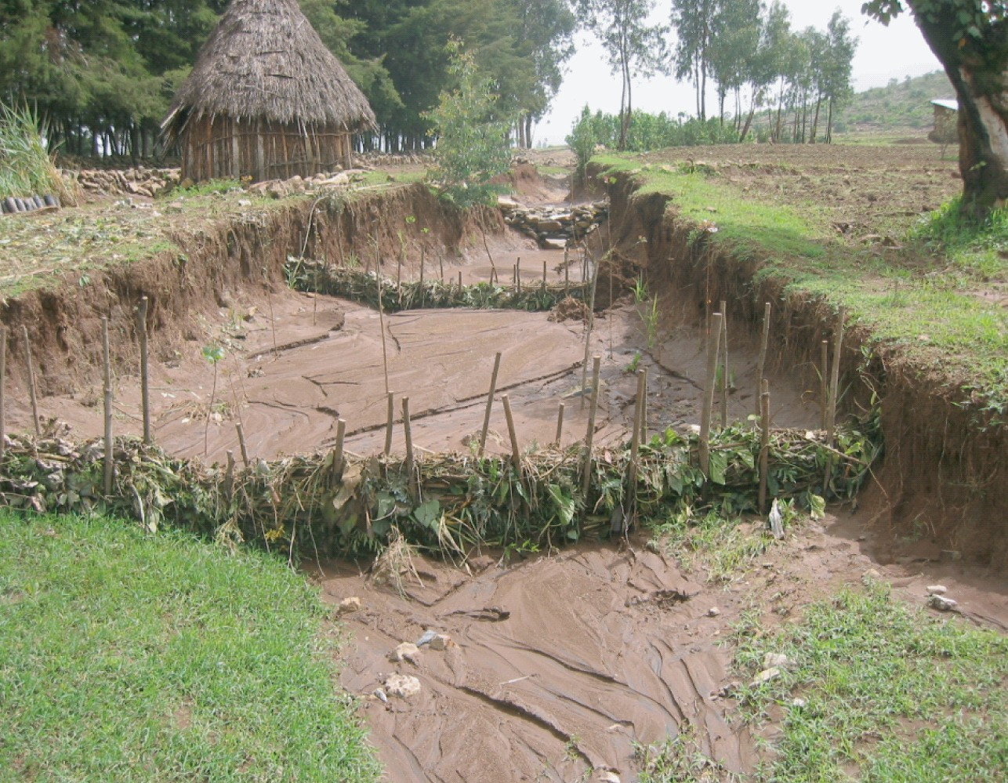

TECHNICAL INFORMATION KIT | (1) Period/phases for implementation |  | (2) Main objective/purpose
GRASS STRIPS ALONG THE CONTOURS | Seedbed preparation before begininng of rains. Planting at beginning of rains. |  | . Grass strips are vegetative barriers made out of grass planted in narrow strips of 0.5 to 1.5 meters width laid out along the contour. Grass strips control erosion rather effectively in gentle slopes but above 5-8% slope their ef- fect decreases.  . While contributing to protect soils against erosion they also provide valuable biomass meant to increase animal feed or used for dif- ferent purposes (eg. rooﬁng, etc.).  . Grass strips cause less interference than other measures as they can easily be crossed by oxen and plough. Moreover, grass strips take out little amount of arable land. Cost of construction is much lower than physical structures.
(3) Suitability and adaptability to local knowledge
. There are grass strips in various parts of the country, often in the form of buffer strips of land left uncultivated and ﬁlling up with spontaneous grass. This is done with the dual purpose of allowing some valuable grass to grow and to control runoff. This system is usually not of permanent nature. Standard grass strips technology was introduced by different projects but did not meet the expected success, mostly because of the difﬁculty to control free grazing.
(4) Main land use and agro-ecology
Grass strips are suitable for cultivated land, mostly in medium and high rainfall areas (moist weyna dega and dega). Within the context of moisture deﬁcit areas grass strips can be applied in semi-arid areas and but not for arid areas.
(5) Potential to increase/sustain productivity and environmental protection (impacts)
. Potential is relevant in medium-high rainfall areas provide control grazing is ensured. This is critical during the ﬁrst year of establishment. Grass strips can replace physical structures effectively usually up to 8% slopes. Exceptions are possible above those ranges but not as effective and/or combined with physical structures and or trees/shrubs hedgerows.
(6) Description of the technology and steps
. Type of grass: Grass species should be perennial and persistent, compete with and suppress weeds, provide good ground cover, slow down the water ﬂow and hence conserve the soil and moisture. Besides, they should provide valuable fodder or other materials of use by the farmers.
. Layout: grass strips are established along the contours. Grass strips are established on a 1m vertical interval, i.e. at 3% slope the distance apart two strips is 33 m and decrease to 7 m at 15% slope. In dry areas, grass strips should not be established on slopes > 8%. For slopes up to 15% they may be planted alternatively with bunds (one grass strip/one bund). The width varies from 0.5 m to 1 m, depending on the density of the plants in the strip. For conservation purposes a width of
0.8-1 m is recommended (Figure 2). The strip is established by broadcasting or sowing/planting seeds/splits/cuttings in two or three lines. The middle row can be sown with a legume to improve the nutritive value of grasses. If the broadcasting method is used, grass seeds can be mixed with the legume seeds and broadcast in the strip.
. Planting technique: For direct sowing a ﬁne seedbed preparation is required. Generally, 0.5-1.5 cm depth is the optimum for most species. When planted manu- ally, rows are opened with a stick at the desired spacing and seed is drilled in the row. Seeds are covered with a thin layer of soil and pressed hard to the soil. Before planting, seeds should be checked for their germination. Alternatvely and for improved efﬁciency and rapid cover use splits and/or grass cuttings or seedlings planted in lines/rows without discontinuity. Spacing between the seedlings/splits should not be wider than 5 cm to guarantee effective grass strip.
. At the time of planting, the handling of planting materials is very important. The grass is cut at about 12 cm above the ground, then the clump is uprooted and trans- ported to the planting site. At planting, the clump is split into pieces including 2 to 3 tillers each to ensure a good establishment (ﬁgure 1). Legume seeds planted in the middle row should be sown by using seeds.
. Planting should be carried out at the onset of rainfall, when the soil is not too wet or too dry. Planting should always ensure good soil-seed/seedling contact by pressing the sides of planting material to soil.
. Harvesting of grasses depend from their use and inner characteristics. Some grass should be cut frequently and at a young stage, other at ﬂowering or ﬁlling time etc. If used as forage usually the ﬁrst harvest is after 3-4 months from establishment, before ﬂowering and cutting grass 10-15 cm above the ground.
. Type of species: should not be aggressive on adjacent crops and act as weeds. There are number of grass species that can be effective in grass strips, such as Rhodes, Andropogon, Setaria, Phalaris, Vetiver, etc. But also native grass (see bund stabilization) which may be more adaptable to local conditions and tolerant to drought. Besides, the advantage of using native grass species is that land users are familiar with the purpose and management of such grasses. Regarding legumes, species such as Stylo, Sirato, Desmodium for drier areas and clovers and medicago in other areas should be tried. However some grass are aggressive with rhizoma and stolons which rapidly colonize the surroundings. Forage/livestock specialists should be consulted prior to the selection of this technique.
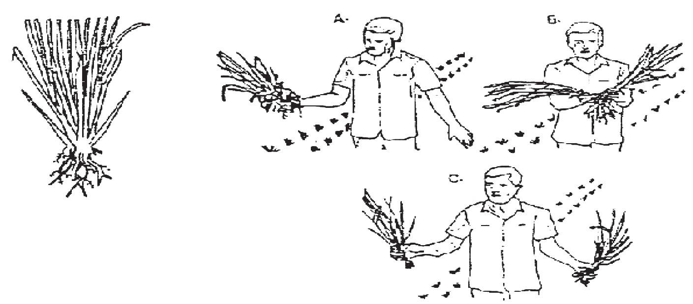  Figure 1. Splitting grass from clumps |  | 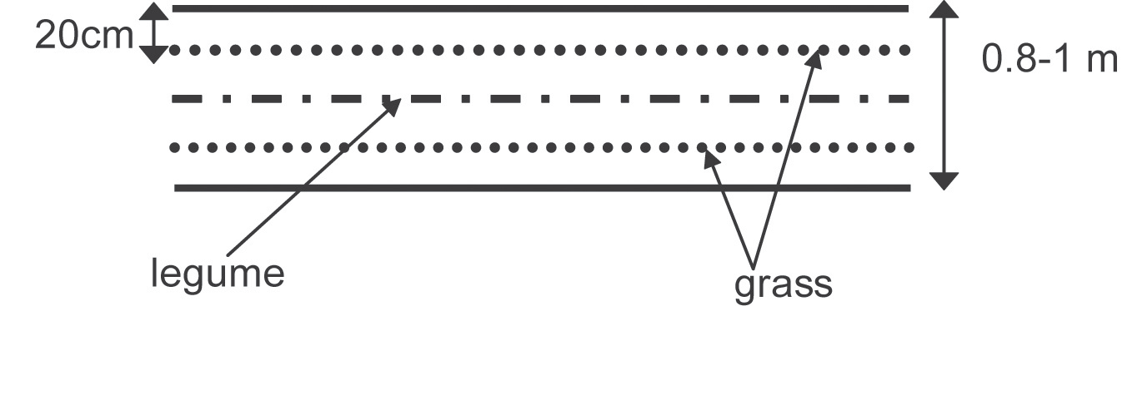  Figure 2. Grass strip (aerial view)
(7) Integration requirements and opportunities |  | (8) Constraints and limitations
1. Grass strips can be integrated with lines of legume shrubs such as pigeon peas, Sesbania, Treelucerne and Acacia saligna planted in dense rows.  2. Integrated with physical structures alternatively in 8-15% slopes. Above such range grass strips are better replaced by physical structures stabilization (less risks of breakages and rapid benching).  3. Control grazing and cultivated land closure recommended. |  | . Although they retard the movement/velocity of water and encourage inﬁltration they do not offer much resistance against erosive rainstorms, particularly at the beginning of the rainy season because the new shoots are not yet developed. Besides, they are easily overgrazed and damaged by animals.  . In dry areas grass strips are less effective in reducing runoff as they provide little storage capacity.

TECHNICAL INFORMATION KIT | (1) Period/phases for implementation |  |  | (2) Objectives/remarks
VEGETATIVE FENCING (VF) | . Drought resistant plants (Euphorbia, Erithrina, Aloes, Sisal, etc.) planted as main fence during the ﬁrst two months of the rainy season.  . Shrubs (Sesbania, Dovalis, Pigeon pea, Trilucerne, etc) and grass species (preferably indigenous) planted at the beginning of the rainy |  |  | - Vegetative fencing (VF) is a conservation practice which consist of a combination of vegetative planting materials resistant to cattle grazing planted in rows and with grass/ legume plant species sowed behind these rows.  - Used to protect and enrich reclaimed areas like closures and gullies, farm boundaries and speciﬁc community assets like ponds. By doing so it also helps controlling runoff and erosion. It is the “ﬁrst level of defence” against animal interference that allow other valuable trees to be planted after the fence is established.  - VF can be exercised as a “grid system” in closures, around reclaimed gullies, and farms, providing increased sense of owner- ship to users.
(3) Suitability, agroecology, adaptability to local knowl- edge
VF is commonly practiced in Ethiopia along farm boundaries using differ- ent local species. Although rarely used for communal and degraded ar- eas, it can expand in such lands as land use certiﬁcation will encourage farmers to protect and develop such areas. Can be used also to fence group of cultivated plots.
(4) Main land use | (5) Technical preparedness
. In all land uses but speciﬁcally recommended for community areas shared amongst households, like closures and gullies. Also recommend- ed along group of farm boundaries and to divide grazing land areas into controlled grazing paddocks. Suitable also around community ponds combined with planting of trees belts behind the VF. | . Local knowledge on how to plant tree/ shrub species. Nurseries organized to supply rest of species.  . Caution required for species that can be irritating for the skin and eyes (Eu- phorbia, etc) and on new species.
(6) Potential to increase/sustain productivity and environmental protection |  |  | (7) Minimum surveying and tools requirements
. Vegetative fencing is the entry point for high value trees and fodder species to be planted behind these fences, creating productive green belts. Vegetative fences implemented over a large area constitute formidable barriers agains erosion and runoff. They create a “conservation webs or nets” capable to trap sediments and moisture in various directions. They also act as windbreaks and re- duce evapotranspiration of cultivated plots.  . Assist in providing psychological security regarding tenure and encourage investment for better land care. Studies in Asia demonstrated that an entire “web” of green boundaries projected over large areas had huge implications in terms of incentives for “intensive land care”, water harvesting (recharge of water tables) and erosion control. Combined with land use certiﬁcation it can generate high level of investments.  . This activity can be combined with many others related to the treatment of hillsides, closures, gully control, etc. A combination of self-help work on farmlands and incentives on communal lands for VF can be used to reach large scale fencing and protection efforts. |  |  | Survey: community and groups assisted to divide closures, gullies and reclaimed plots into compartments based on agreed size and conditions of the area (soil, slopes). The horizontal part of fences should follow contours as much as possible.  Tools: farmers tools sufﬁcient (machetes, small hatchets, axe and hooks).
(8) Min. technical standards, steps and work norm
Main Fence: made preferably of 2 rows of species planted staggered such as Eu- phorbia candelabra (tall Euphorbia or “Koal-koal”) and ﬁnger Euphorbia (“Kincheb”), Erithrina (“Korch”), Aloe, Sisal and other plants.  Spacing of plants in main fence: 50 cm between rows and 20 cm within row, pos- sibly using a combination of the above species. Single row also possible - plants 10 cm or very close apart based upon local knowledge (necessary to obtain a tight and continuous vegetative fence).  Plantation of grass/legumes behind main fence: this is to further support and make the fence thicker and more productive. Direct sowing of Sesbania, Pigeon peas, Acacia Saligna, Treelucerne and local grass strips is recommended. Plant one line of grass as close as possible to the fence or between the two rows. Plant one or two rows of legume shrubs by opening a furrow of 20cm behind the fence.  In areas already treated with hillside terraces place single row VF following lower part of stone raiser (see Figure 3). For measures like trenches, eyebrows and simi- lar structures place single row VF in between series of those structures based on the size of plots. WORK NORM: 40 person days/km |  | 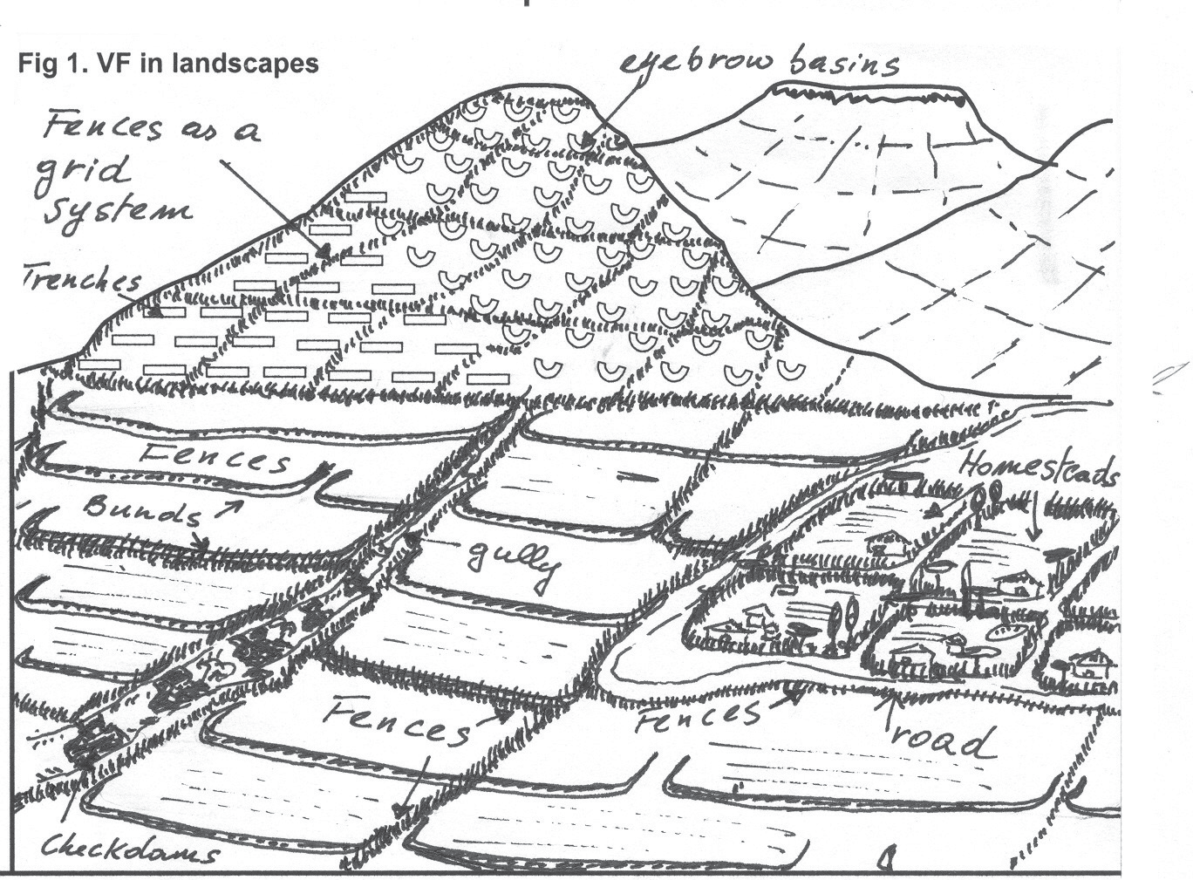
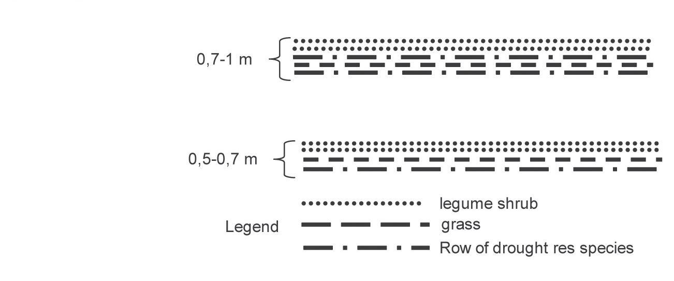  Figure 2 Example of vegetative fence |  | 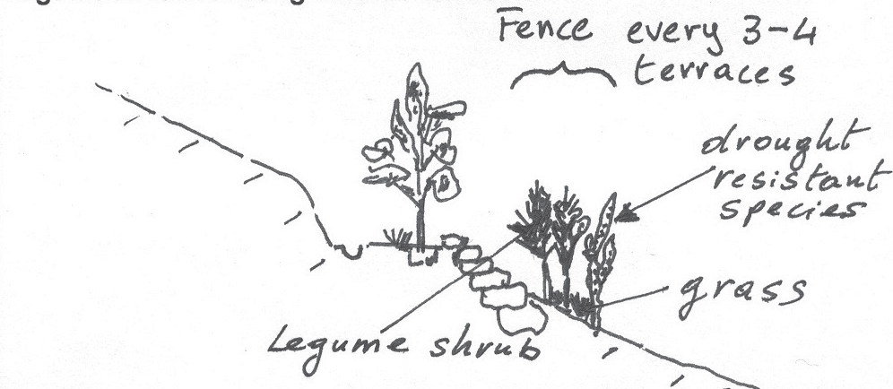  Figure 3 Vegetative fence along hillside terraces
(9) Integration |  | (10) Management requirements
. Can be integrated with all possible watershed treatment measures on hillsides, gullies, grazing lands and farms.  . Need participatory planning for sharing/fencing areas and land use arrangements. Would strongly beneﬁt from the land use certiﬁcation strategy.  . Some of the planting material are needed to be grown in nurseries and/or part of speciﬁc seed collection strategies. |  | Reﬁll the ﬁrst compost pit one month before the end of the composting pro- cess taking place in the second pit and repeat the same procedure. By this system you can produce compost three times a year (see ﬁgure 80) or more if the time of decomposition is faster.
 |  | (11) Institutional responsibility
. Fully on community members (commitment to mgt.).
. DAs and wda experts - technical support and mgt.

